# Report 2: System Analysis & Architectural Design Report (Design Phase)

## System Overview

* Purpose and Functionality: The CorporationSecurity system manages corporate assets, risks, and controls, tracking user actions via audit logs. It supports risk assessment, mitigation planning, and compliance monitoring.
* Intended Users: System Administrators, Risk Managers, Operations Staff.
* Target Platform: Web-based application with SQL Server database, accessible on desktop and mobile browsers.

## UML Diagrams

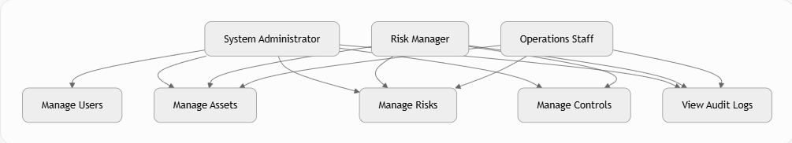

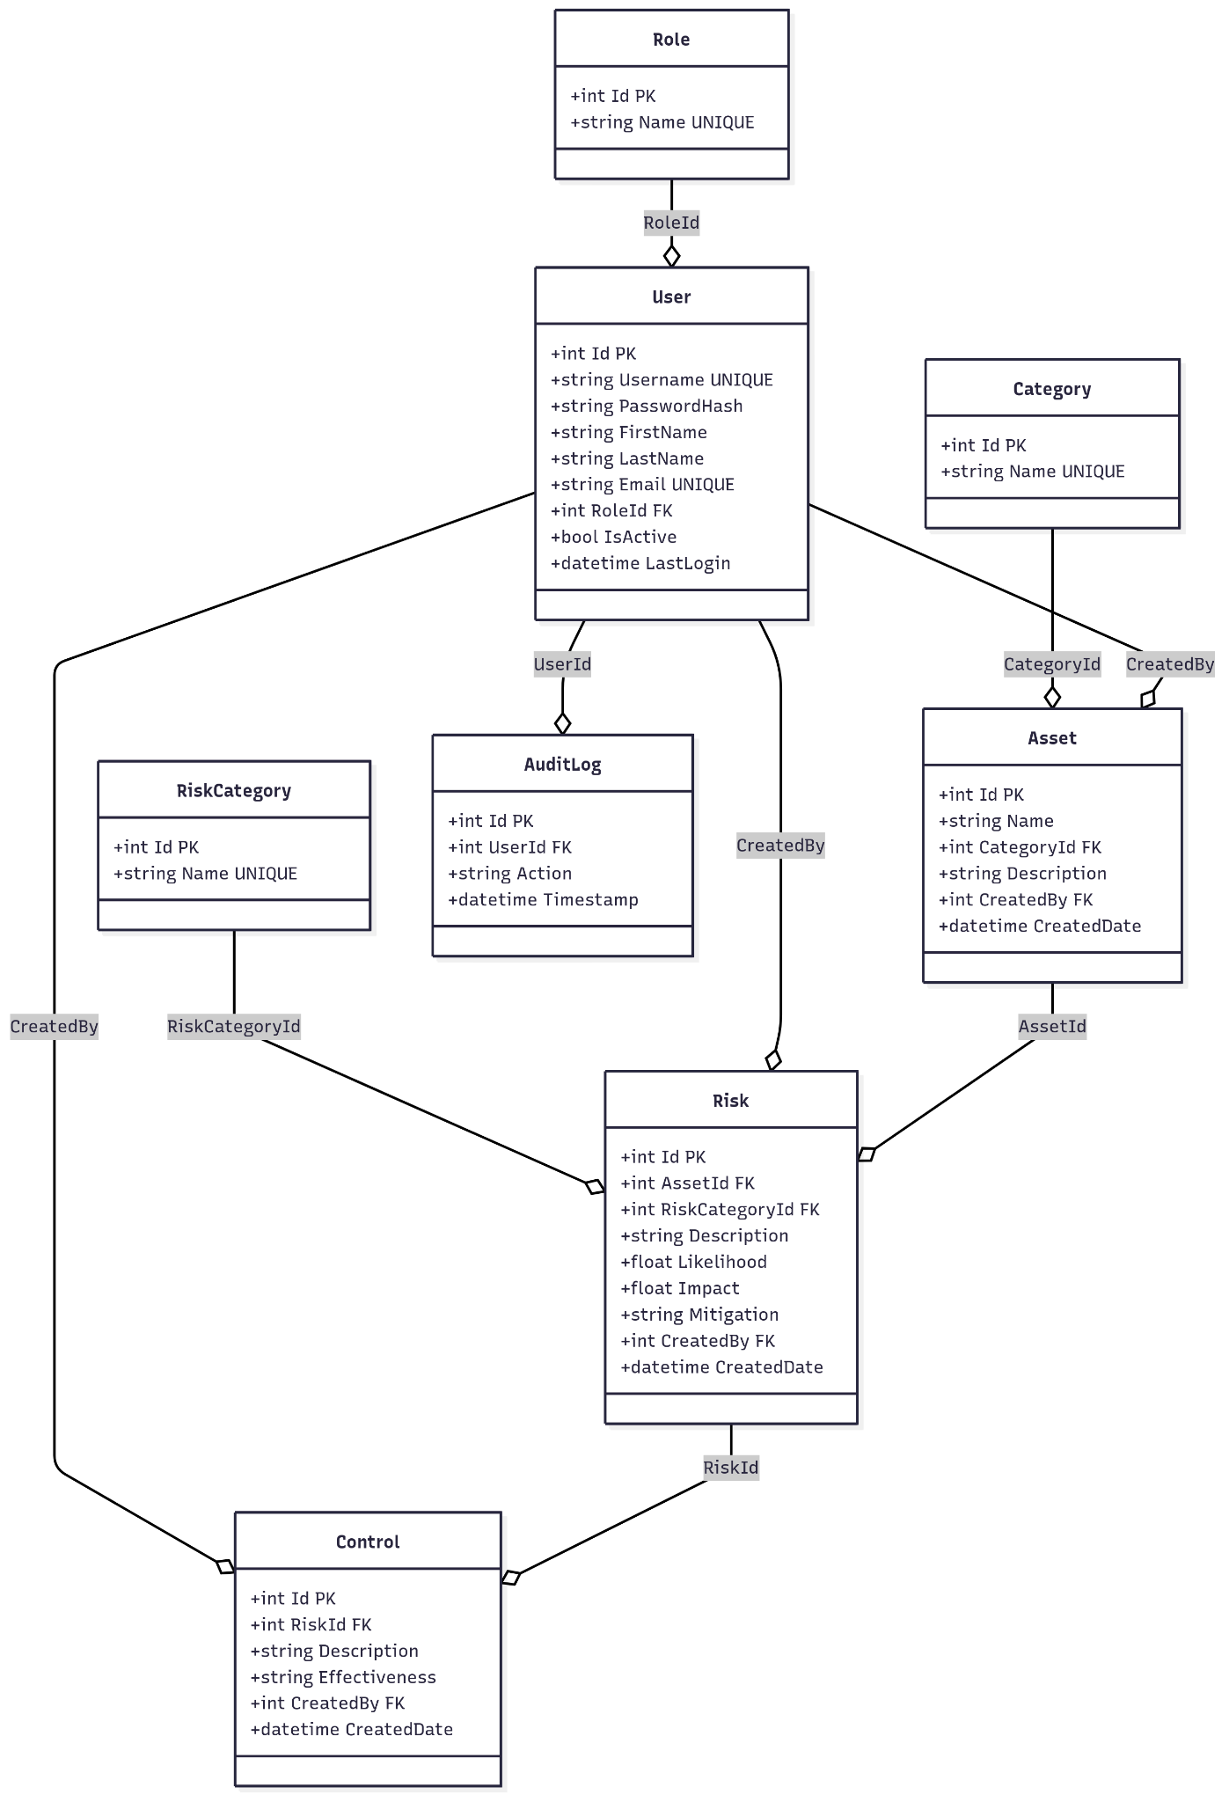

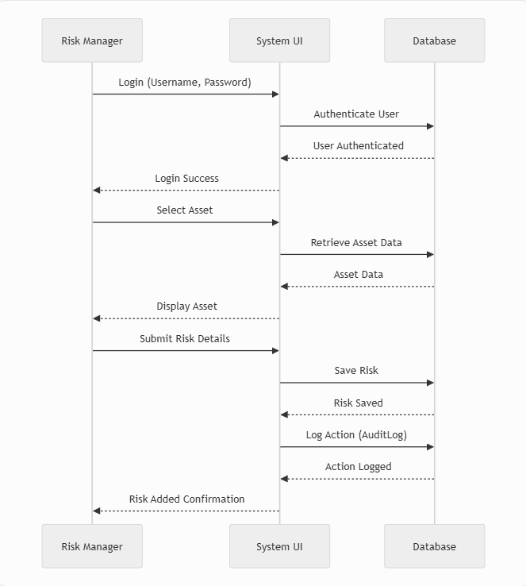

## Database Design

* Entity-Relationship Diagram (ERD):
  + Entities and Relationships:
  + Role: Linked to User (1:N).
  + User: Links to Asset, Risk, Control, AuditLog (1:N).
  + Category: Linked to Asset (1:N).
  + RiskCategory: Linked to Risk (1:N).
  + Asset: Linked to Risk (1:N).
  + Risk: Linked to Control (1:N).
  + Description: Visualizes entities and their relationships, with foreign keys enforcing referential integrity.
* Database Schema:
  + Role: Id (PK), Name (UNIQUE).
  + User: Id (PK), Username (UNIQUE), PasswordHash, FirstName, LastName, Email (UNIQUE), RoleId (FK), IsActive, LastLogin.
  + Category: Id (PK), Name (UNIQUE).
  + RiskCategory: Id (PK), Name (UNIQUE).
  + Asset: Id (PK), Name, CategoryId (FK), Description, CreatedBy (FK), CreatedDate.
  + Risk: Id (PK), AssetId (FK), RiskCategoryId (FK), Description, Likelihood (0-1), Impact (0-1), Mitigation, CreatedBy (FK), CreatedDate.
  + Control: Id (PK), RiskId (FK), Description, Effectiveness (Pass/Fail/Pending), CreatedBy (FK), CreatedDate.
  + AuditLog: Id (PK), UserId (FK), Action, Timestamp.
* Table Descriptions:
  + Role: Defines user roles (e.g., System Administrator).
  + User: Stores user credentials and status.
  + Category: Categorizes assets (e.g., IT, Finance).
  + RiskCategory: Categorizes risks (e.g., Cybersecurity).
  + Asset: Tracks corporate assets.
  + Risk: Records risks associated with assets.
  + Control: Manages risk mitigation controls.
  + AuditLog: Logs user actions for accountability.

## User Interface (UI) Mockups

* Login Screen: Fields for Username, Password; “Login” button.
* Dashboard: Displays assets, risks, and controls overview; navigation to manage each.
* Asset Management: List of assets with options to add/edit/delete.
* Risk Management: Form to add/edit risks, linked to assets and categories.
* Control Management: Form to add control based on risk that is registered.
* User Management: Datagrid to display and control user login, roles, etc.
* Audit Log View: Table showing user actions with filters for user and date.

## CI/CD Planning

* Version Control: Git (GitHub).
* Testing: Unit tests (XUnit)